Municipal formation Goryachiy Klyuch city

Shop building

General description and location of the site

Address: Krasnodar Territory, Goryachiy Klyuch, st. Baku, st. Gorbunova, 14A
Cadastral number of the plot: 23:41:0102001:3404
Area: 644 sq.m.
Land category: land of settlements
Type of permitted use: Free-standing, built-in or attached objects: shops 4.4
Owner information: State property
Copyright holder: MO Administration
Hot Key

City Goryachiy Klyuch

Infrastructure support
No information

Power-1 cubic meters per day
Diameter-110mm
Water quality - SanPiN 1.2.3685-21

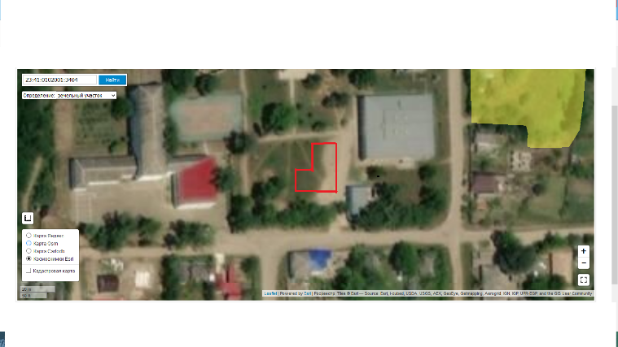
Highway FAD "Don M-4";
Distance - 3 km

Pressure-0.005 MPa
Diameter -108 mm

Калининская
railway station "Goryacheklyuchevskaya track station" of JSC "Russian Railways";
Distance – 21 km

Contact details
Goryachiy Klyuch city administration
353290, Krasnodar Territory, Goryachiy Klyuch, st. Lenina, 191 Phone / fax: (86159) 3-58-80. Email address: invest@admgorkluch.ru

