Municipal formation Goryachiy Klyuch city
cafe construction

General description and location of the site

Address: Krasnodar Territory, Goryachiy Klyuch, аrt. Saratovskay
Cadastral number of the plot: 23:41:0109003:2139
Area: 0,5 hectares.
Land category: land of settlements
Type of permitted use:
Public catering-4.6
Information about the owner: land, state ownership of which is not delimited
Copyright holder: MO Administration
Hot Key

Infrastructure support
Information is absent
Свобо
Ближа
Power - 10 cubic meters. per day,
– Diameter-100mm,
Water quality - SanPiN 1.2.3685-21

Gas pipeline: absent

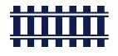
Railway station "Goryacheklyuchevskaya station of the way"JSC "Russian Railways";
Distance – 6,3 km

Highway FAD “M-Don";
Distance – 3 km.

City Goryachiy Klyuch

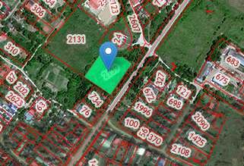

Калин

Contact details
Goryachiy Klyuch city administration
353290, Krasnodar Territory, Goryachiy Klyuch, st. Lenina, 191 Phone / fax: (86159) 3-58-80. Email address: invest@admgorkluch.ru

